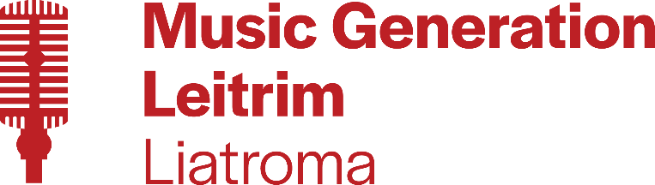

Music Summer Camp

Venue: “The Island Theatre”, Ballinamore (Community Centre)
Date: Monday 25th - Friday 29th July, 2022
Time: 10.30am - 1.30pm
Age Range: 5 - 13 years old
Cost: €50 per child (Family discount available)

Does your child have any specific individual requirements you would like us to be aware of? (e.g. personal support, access, medical, etc.)
__________________________________________________________________________
__________________________________________________________________________
Child’s Name: ………………………………………………………………………………..................
Child’s Age: ..………………………………………………………………………………………………….
Child’s Date of Birth……………………………………………………………………………………….

Parent/Guardian Name: …………………………………………………………………………………
Parent/Guardian Email Address: …………………………………………………………………….
Parent/Guardian Mobile Number: ………………………………………………………………….

*Photo Consent* - Our funders request that we take occasional photos/videos of
“Music Generation Leitrim” activities.
I hereby give my consent for “Music Generation Leitrim” to take photos/videos which
may be used for promotional purposes on social media and local/national press.
Parent/Guardian Signature: …………………………………………………………………………..
Date: ………………………………………………………………………………………………………………

